Supports of uterus

Pelvic floor support
Urinary and genital tracts have common interdependent support system
These supports are essential to hold the pelvic viscera and prevent them from vertical descent

Pelvic organ prolapse
Clinical note: The pelvic floor support is important in understanding pelvic organ prolapse (POP)
POP - herniation of the pelvic organs
Prolapse may involve uterus, vaginal cuff, bladder, small or large intestine (various combinations possible)

Delancey’s three levels of pelvic floor support
Structures supporting uterus and vagina are divided into three levels
Level 1 - Suspension
Level 2 - Attachment
Level 3 - Fusion

Level 1 – Suspension
Suspending structure attached to the lower part of the uterus - parametrium
Suspending structure attached to the vagina - paracolpium
Parametrium - is made of cardinal ligament / uterosacral ligament complex
Parametrium continues down as paracolpium
Level 1 structures suspend upper part of vagina and cervix from above

Uterosacral ligament complex
This is a part of continuous endopelvic fascia
Endopelvic fascia is a continuous system of sheaths over many pelvic viscera
Has collagen, elastin and smooth muscles
Endopelvic fascia has several condensations - called ‘ligaments’. These are fascial condensations and are not true ligaments.
Origin: in the region of S2 to S4 sacral vertebrae (with no bony attachment)
Insertion: into the dorsal aspect of uterine cervix and to the upper third of the vagina (posterior wall)
Components:
Superficial - covered by peritoneum
Deep - retroperitoneal
Relations - at the cervix - it is close to ureter

Cardinal ligament
Nomina anatomica term - parametrium
Unofficial terms - Tranverse cervical ligament / Mackenrodt ligament
Other terms - Uterosacral (sacrocervical) ligament
Structure: mesentery like structure covering the neurovascular elements from the internal iliac artery to the lateral aspect of the cervix and vagina
Anatomical existence of cardinal ligament is less defined. When the paracervical and pararectal spaces are opened up with blunt dissection, cardinal ligament (areolar tissue around the vessels) becomes more evident.
[TIP]Clinical note: Uterine prolapse occurs when the cardinal-uterosacral ligament complex gets lax or breaks
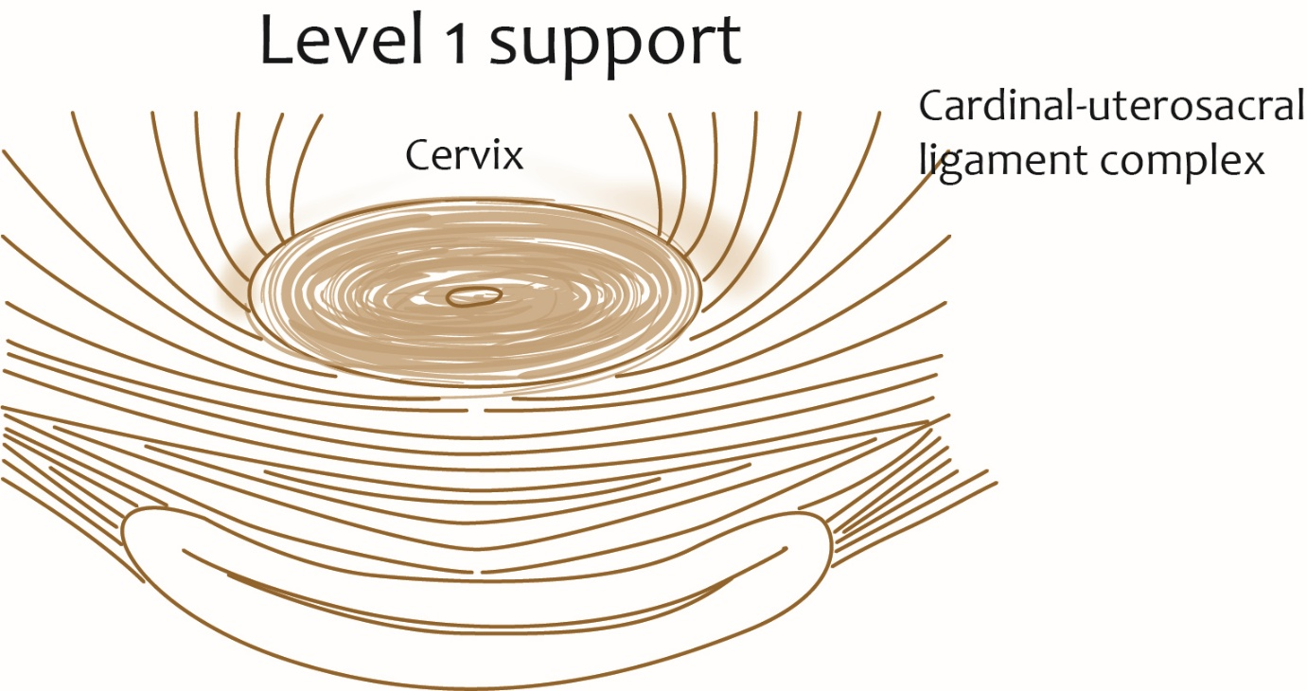

Level 2 – Attachment
Middle third of vagina is supported by attachment of paracolpium between the vaginal wall and lateral pelvic wall
Forms arcus tendineus fasciae pelvis (ATFP) and fascia over the levator ani muscles

ATFP - arcus tendineus fasciae pelvis or white line
​​​​​​​Is the thickened condensation of the fascia over the iliococcygeus
Origin: ischial spine
Insertion: inner aspect of the pubic symphysis
It forms H shaped box like configuration around the distal vagina
[TIP]Clinical note: Damage to the mid-level support of the vagina (level 2) results in cystocele and/or rectocele
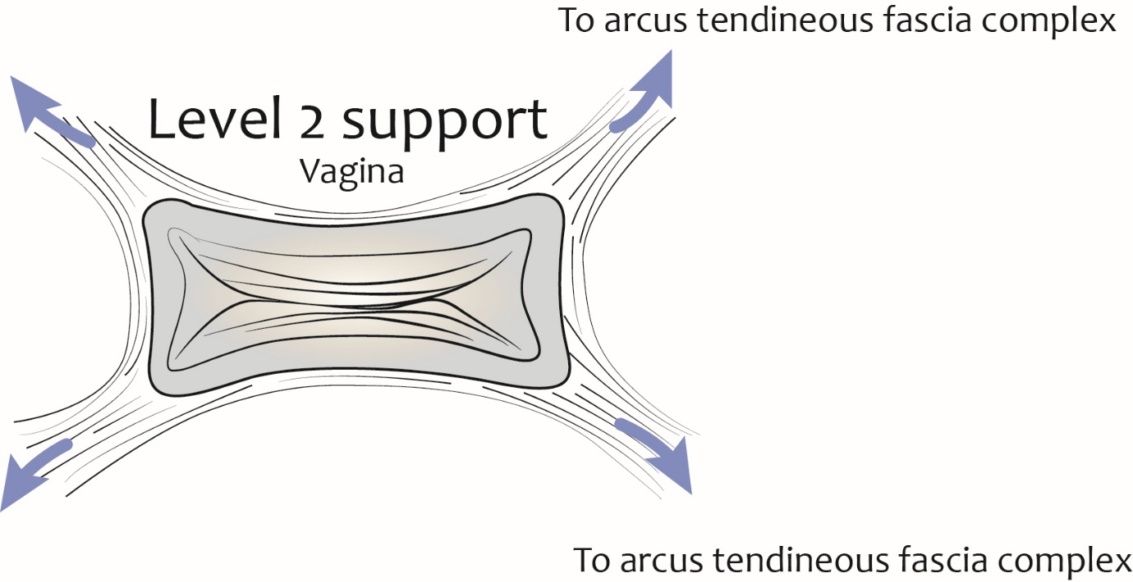

Level 3 – Fusion
2-3 cm above the hymenal ring, vagina is fused in the following fashion
Laterally - levator ani muscles (urogenital diaphragm)
Posteriorly - perineal body
Anteriorly - blends with urethra
Superficially - perineal membrane with muscles of deep perineal space

[TIP]Clinical note:
Anterior disruption of level 3 support results in urethral hypermobility and stress incontinence
Posterior disruption results in distal rectocele and perineal descent
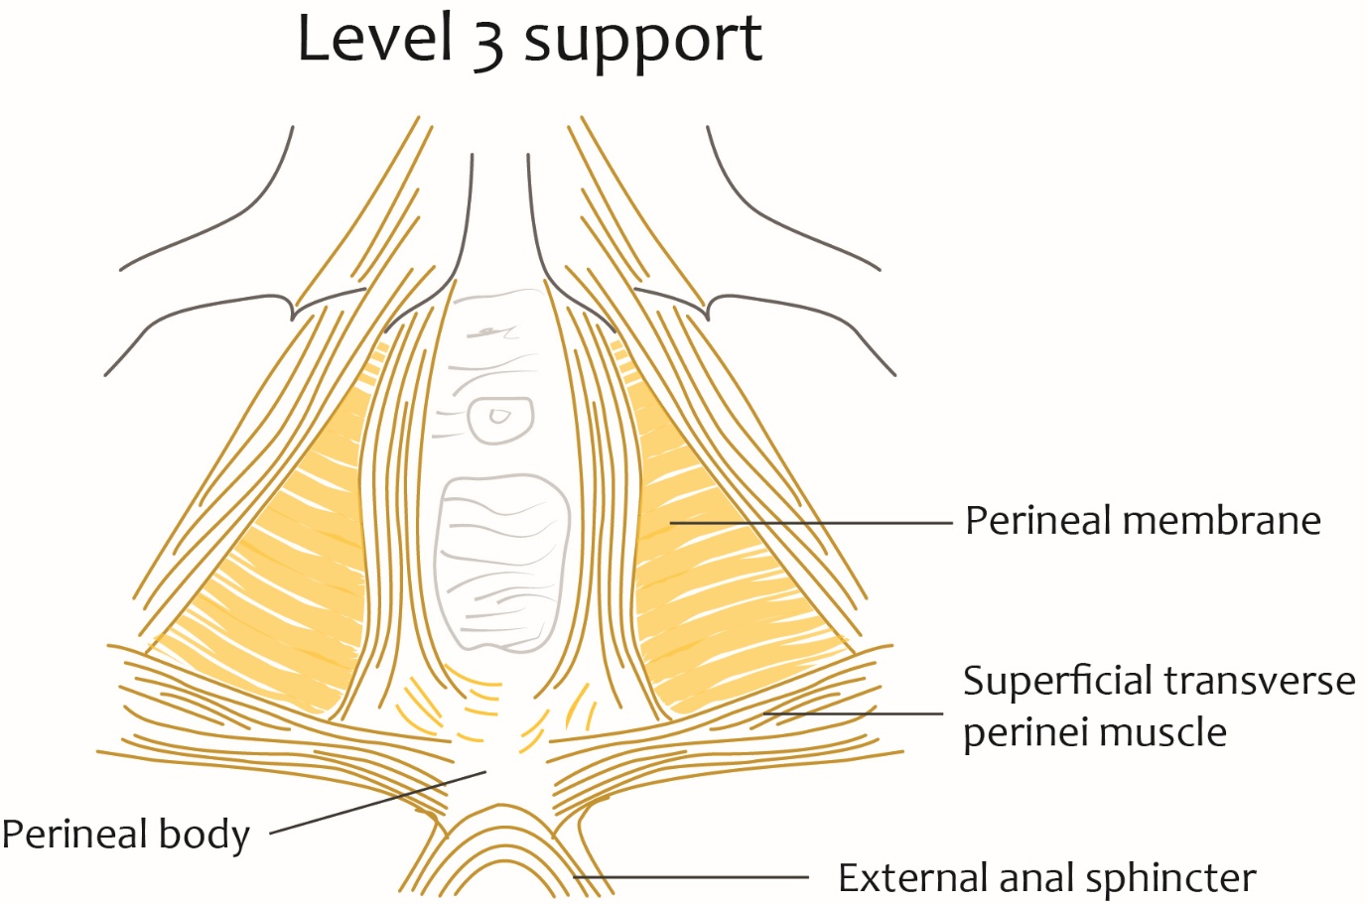

Pelvic diaphragm (of pelvic floor)
Most important support of the pelvic viscera including the uterus
funnel-shaped fibromuscular partition in the pelvis
Composition:
Components of pelvic diaphragm
- Levator ani muscles
- Coccygeus muscles
- Superior and inferior fascia enclosing these muscles
It forms the roof of ischiorectal fossa

Levator ani
Broad, thin muscle at the pelvic floor
Critical role in pelvic support
Components
Pubococcygeus
- Levator prostate in males and pubovaginalis in females
Puborectalis
Iliococcygeus

Pubococcygeus
Origin:
From the inner surface of the body of pelvis
From the tendinous arch of obturator fascia
Insertion:
Fibres from pubis are inserted into the perineal body
Fibres from the tendinous arch are inserted into the anococcygeal raphe and to the coccyx
Subdivisions
Anteriorly
In males - fibres around the prostate forms - levator prostate
In females - fibres around the vagina and cervix form pubovaginalis
Pubovaginalis - acts as vaginal sphincter
Posteriorly
U shaped sling around the rectum forms puborectalis
Puborectalis blends with the longitudinal fibres of the rectum
Puborectalis - creates anorectal angle. It is one of the important factors for the anal continence

Iliococcygeus
Origin:
From the posterior part of the tindinous arch
From the ischial spine (pelvic surface)
Insertion: into the anococcygeal raphe and to the sides of the coccyx

Ischiococcygeus
Origin: apex of ischial spine and sacrospinous ligament
Insertion: coccyx and to the S5 segment of sacrum
Sacrospious ligament - considered as degenerated tendon of the coccygeus

Kegel exercises
Voluntary contractions of all the perineal muscles
Strengthen all the striated muscles in the perineum
Uses -
- Ameliorate erectile dysfunction due to venous leakage
- Help men control premature ejaculation
- Treat urinary incontinence in females
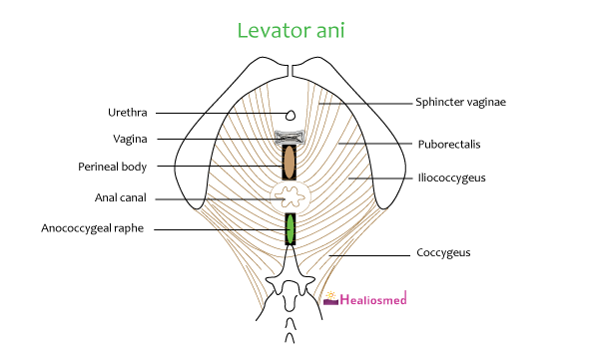

Ligaments of uterus and cervix
- Broad ligament
- Round ligament
- Cardinal ligament
- Uterosacral (sacrocervical) ligament
- Anterior uterine (uterovesical) ligament
- Posterior uterine (rectovaginal) ligament
- Pubocervical fascia
- Utero-ovarian ligament
- Rectouterine ligament

Broad ligament
It is the mesentery of the uterus, tubes, and ovaries
It is the large peritoneal fold enclosing parametrium
Extends from body of uterus to the lateral pelvic wall
Compartments of pelvis
Uterus with broad ligament on either side divides the pelvis into two parts
- Anterior or vesicouterine fossa
- Posterior or rectouterine fossa (cul-de-sac of Douglas)
Broad ligaments are of no mechanical support to the uterus and cervix
Borders of broad ligament
- Medial border - lateral edge of uterus, encloses uterine vessels
- Lateral border - related to lateral pelvic wall
- Superior border - envelops the uterine tube, vessels, ovarian ligament and round ligament (anteriorly)
- Inferior border - extends over the floor of the true pelvis
Other named parts of the broad ligament
Mesovarium - posterior layer of the broad ligament attached to the anterior margin of the ovary
- It has ovarian blood vessels and nerves
Mesosalphix - part of the broad ligament between the uterine tube and ovary
- It has uterine tube, round ligament, ligament of ovary, paraoophoron and epoopharon
Suspensory ligament of ovary - part lateral to ovary
- It has ovarian blood vessels and nerves
Mesometrium - part of the broad ligament below the mesovarium
Parametrium - thick connective lateral to the lower uterine segment and cervix

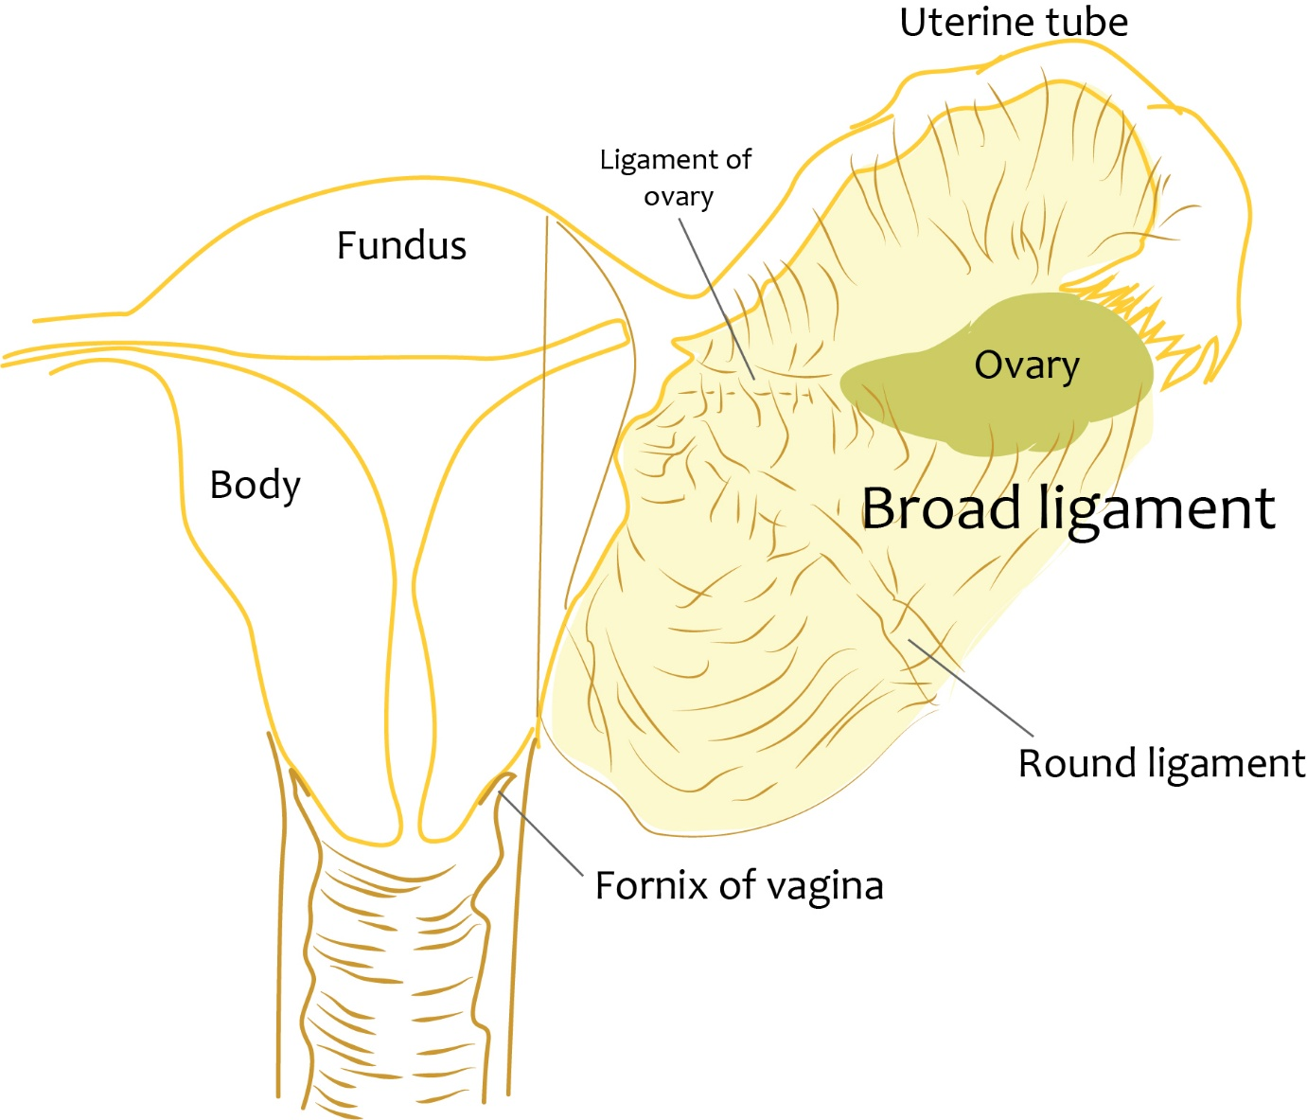

Round ligament
Remnant of gubernaculum overii
Arise from - upper part of the lateral aspect of the body (at the junction of the uterine tubes)
Course
Travel anteriorly and laterally through mesometrium
Leaves pelvis through deep inguinal ring
Passes though the inguinal canal
Terminates - near mons pubis

Pubocervical fascia
Thick anterior connective tissue in relation to the cervix and vagina where urethra is embedded

Utero-ovarian ligament or ovarian ligament
Derived from gubernaculum ovarii
Attaches the ovary to the body of the uterus

Rectouterine ligament
Extends between the pericervical ring to the upper vagina
[TIP] Broad ligament, mesovarium, mesosalphix and round ligament do not play a role in support of pelvic organs

Clinical importance - Pelvic Organ Prolapse
​​​​​​​Uterovaginal prolapse - prolapse of the uterus, cervix and upper vagina
Urethrocele - Prolapse of the lower anterior vaginal wall involving the urethra only
Cystocele - Prolapse of the upper anterior vaginal wall involving the bladder
Cystourethrocele - prolapse of the urethra and bladder
Enterocele - Prolapse of the upper posterior wall of the vagina usually containing loops of small bowel
Rectocele - Prolapse of the lower posterior wall of the vagina involving the rectum bulging forwards into the vagina

Clinical importance - Grading of POP
Grade 0 – no prolapse
Grade 1–halfway to hymen
Grade 2 – to hymen
Grade 3 – halfway past hymen
Grade 4 –maximum descent

